B
A
Supplementary Figure 1. Alpha diversity of the faecal microbiota community between (A) term and preterm infants and (B) time points based on Pielou’s evenness, Simpson’s, and Shannon’s indices. p < 0.05 (*), p < 0.01 (**), p < 0.001 (***), were regarded as statistically significant.

Supplementary Figure 2. Taxonomical classification and diversity of gut microbiome of term and preterm infants. The overall (A) phylum and (B) genus distribution of bacterial taxa in term and preterm across five collection time points. Reads that were not aligned to reference alignment are denoted as “unclassified”.
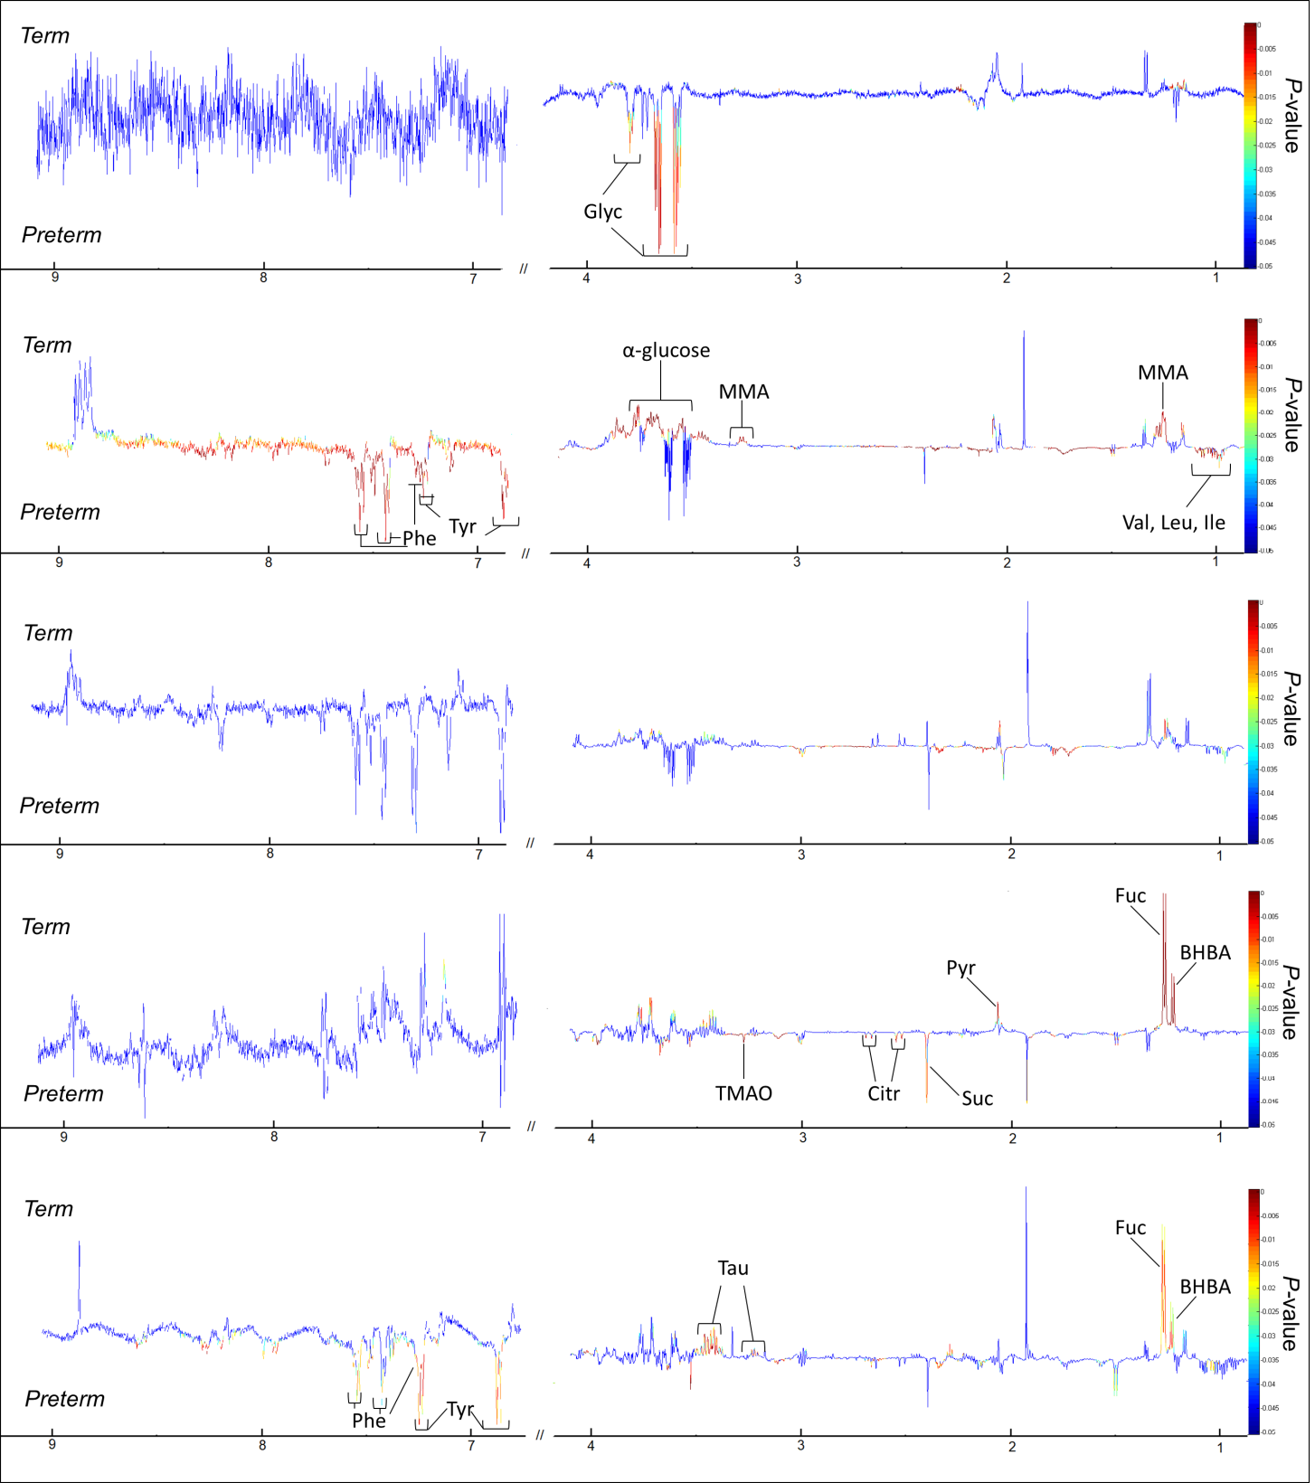
E
D
C
A
B
Supplementary Figure 3. Covariance plots showing the colour-coded significance of stool metabolite profiles calculated using permutation test between term and preterm infants from (A) meconium, (B) week 1, (C) week 2, (D) month 6 and (E) month 12. Key: BHBA, β-hydroxybutyrate; Citr, citrate; Fuc, fucose; Glyc, glycine; Ile, isoleucine; Leu, leucine; MMA, methylmalonic acid; Phe, phenylalanine; Pyr, pyruvatoxime; Suc, succinate; Tau, taurine; TMAO, trimethylamine-N-oxide; Tyr, tyrosine; Val, valine.

